BLETCHINGDON PARISH COUNCIL – RISK ASSESSMENT

Area for Risk assessment – Childrens play area and equipment at the playing field, Oxford Road.
Risk detail | Hazard | Harm to | Likelihood | Severity | Risk Level | Control Measures | Risk Reduced
Sanitisation | Play equipment  Benches  Fence and gate | Public | 3 | 5 | 15 | A deep clean can be done before opening but once open, we cannot guarantee that it will remain clean and sanitised. | No.
Social Distancing | Parents/carers – Display a poster to remind parents/carers of the rules  Children – can be reminded by their parents/carers. | Public | 3 | 3 | 9 | Signage | Yes.
Facility for providing cleaning/sanitising equipment | If we provide equipment and materials to enable playground users to clean the equipment before and after use, we cannot guarantee that people will use it or guarantee that it won’t be taken away. | Public | 3 | 5 | 25 | We cannot put sufficient controls in place to guarantee the equipment is kept clean/sanitised. | No.
Track and Trace capability | It is not possible to generate any sensible track and trace details beyond an immediate group. | Public | 5 | 5 | 25 | We do not have the capacity to put sufficient controls in place to keep track of everyone using the playground at any time. | No.
Assessors’ Comments
Because of the open nature of the Playground, there is no way to guarantee it is safe to use so the decision has been made to keep the playground closed.
The Parish Council are unable to guarantee the safety of potential users as we do not have the resources to manage users accessing the playground and have no sufficient track and trace capabilities.

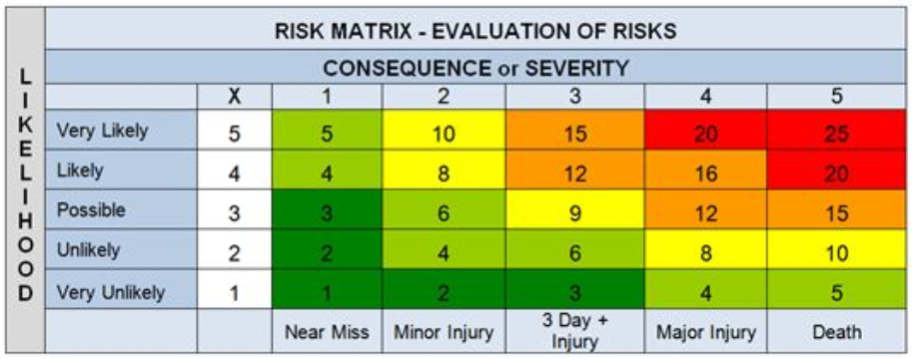

Risk Assessment carried out by Date
Tony Saunders & Fiona Mason 03/07/2020
Overall Max Risk Level
25

